

**ELECTRICAL AND ELECTRONICS ENGINNEERING**

**ELECTRICAL TECHNOLOGY**

**LEVEL:III**

**STREAM:B**

**TOPIC: TURNING ON FAN ACCORDING TO THE TEMPERATURE READING**

**PREPARED BY: UKWISHAKA ADELINE**

**NTIREKABAYO EMMANUEL**

**ABSTRACT**

this project entitled “**turning on fan according to the temperature reading**” is based on AT mega328 microcontroller and temperature sensor called LM 35,This sensor is a precision temperature sensor whose output is linear proportionalto Celsius temperature. If you are sitting in a room and feeling cold and you want your fan to be automatically turned on and then off after sometime when room temperature is increased, then this project helps you to control your fan automatically according to the temperature. Here we are controlling a fan with Arduino based on the temperature. the LM35 is rated to operate from -550centigrad to 1500 centigrade with a linear scale factor of +10mv/0c. therefore when the temperature sensor, sense temperature above or equal to 500 automatically it turns on the fan to give same air in the room,we supply our Arduino with power via USB to your laptop or connect 12v adapter, thermistor and relay is connect as power circuit diagram. The analogue pin [A0]is used to check the voltage of thermistor pin at every moment,as the temperature increases than 55degree Celsius Arduino turned on pin7 high [where fan is connected]when the temperature goes below 55 Celsius degree Arduino turns off the fan by making the pin7 low . This project is very useful in temperature-controlled fan.

**PROBLEM STATEMENT**

It’s a difficult to the most of the people for working during the dry season with high temperature like sitting in the halls ,churches and meeting rooms whenthe temperature increases this change of temperature values, this change of temperature will disturb and even Couse bad effect to the people on their work so for this reason I design and implement this project entitled “**turning on fan according to the temperature reading**“ which will provide fresh air on needed condition accordingly.

**Block diagram**

Temperature sensor

Arduino uno

**Diagram description**

The LM35 temperature sensor will be used to detect a temperature when it reaches above or equal 500c automatically the red led will indicate if the there is high temperature and hence the Arduino will receive and process the signal from the sensor and turns on a dc fan with the yellow led to indicate that the fan is ON and when the temperature is below 500C the fan will be OFF.

SOURCECODES

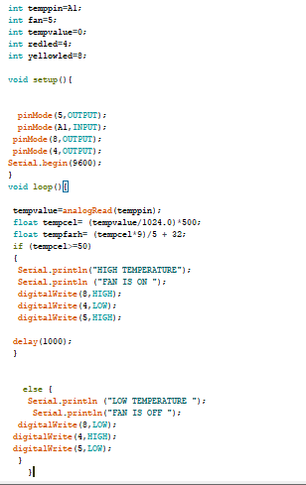

**CIRCUIT DIAGRAM IN PROTEUS**

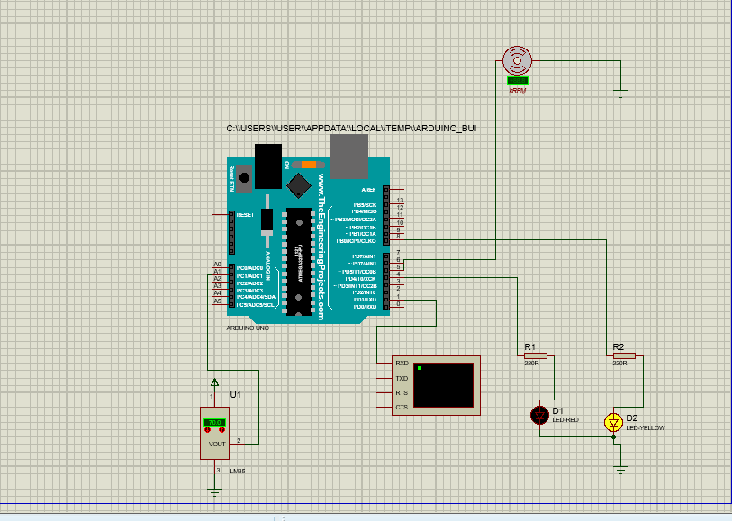

**CIRCUIT IN FRITZING**

